Long Creek Invitational Information

- Roll @ 4:50 AM
- Depart @ 5:00 AM
- Location: Zipp Park off the corner of Klein road and 1044 Behind Long Creek High School
- Zipp Family Sports Park: 16555 W. Klein Rd. New Braunfels, TX 78130
- Course: Our course is predominantly grass/dirt situated on Zipp Park
- Schedule/Divisions: Rollin Start beginning at 7:30, races will begin as soon as the previous race ends.
- 5A-6A VG - 5k
- 5A-6A VB- 5k
- 1A-4A VG- 2 Miles
- 1A-4A VB- 5K
- JV Girls - 2 Miles
- JV Boys- 5K
Milesplit Link: https://tx.milesplit.com/meets/759939-long-creek-hs-invitational-xc-2026
Course Map
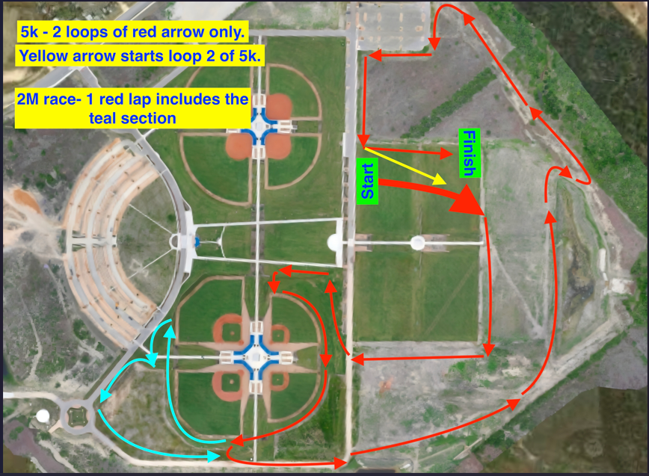

Parking Map:
